**Professional Readiness for Innovation, Employability and Entrepreneurship Project Report for Week 3**

**Project Tile:** AI-powered Nutrition Analyzer for Fitness Enthusiasts

**Team ID:** PNT2022TMID48053

**GitHub ID:**[IBM-Project-](https://github.com/IBM-EPBL/IBM-Project-24498-1659943754)53441[-](https://github.com/IBM-EPBL/IBM-Project-24498-1659943754)1665376120

WEEK 3(8-10 September):

In week 3, we prepared and submitted the empathy map which is related to different emotions like pains,fear etc related to project.We Prepared list of problem statements related to our project that has different shareholders associated with our project.We Attended all the technology training program on 8th of September.Completed the quiz on 9th of September.We Completed Assingment-1 that is related to basics of python and submitted it in Github.

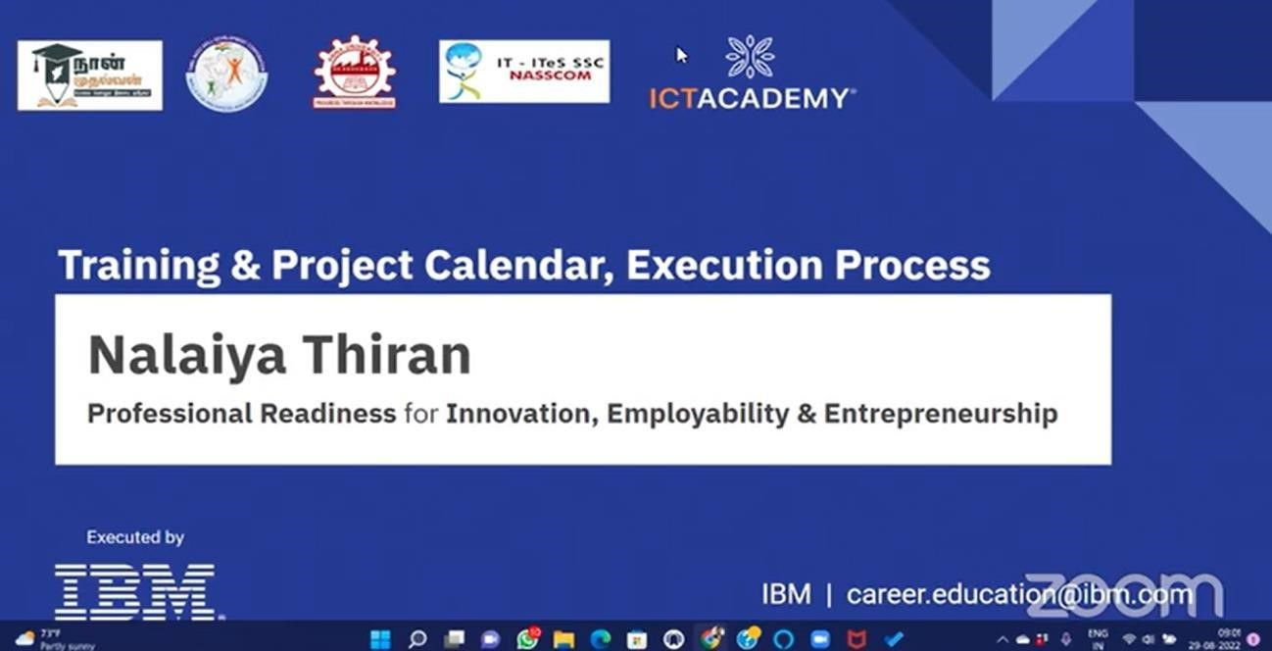

* Our **Day 1 Session** was on **September 8th** which was based on the basics of python

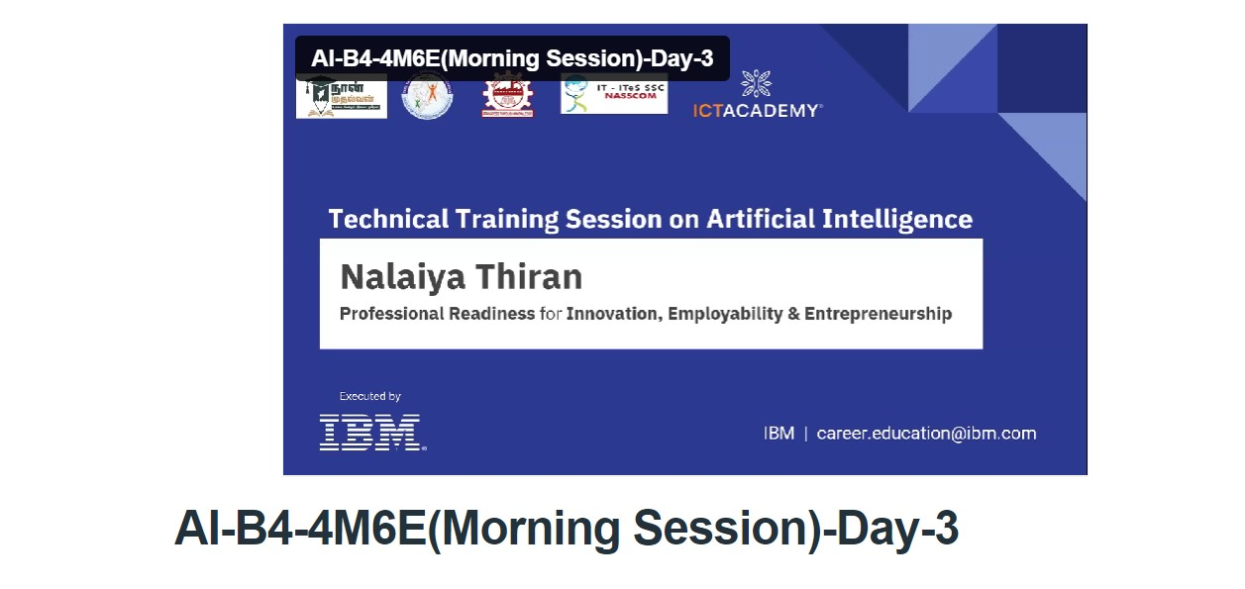

* Our Day 4 Session was on September 10th We had Listed the ideas by organizing the brainstorming session and prioritized the top 3 ideas based on the feasibility & importance.

